HW 23: Multi-Step Inequalities Date: Jan. 7
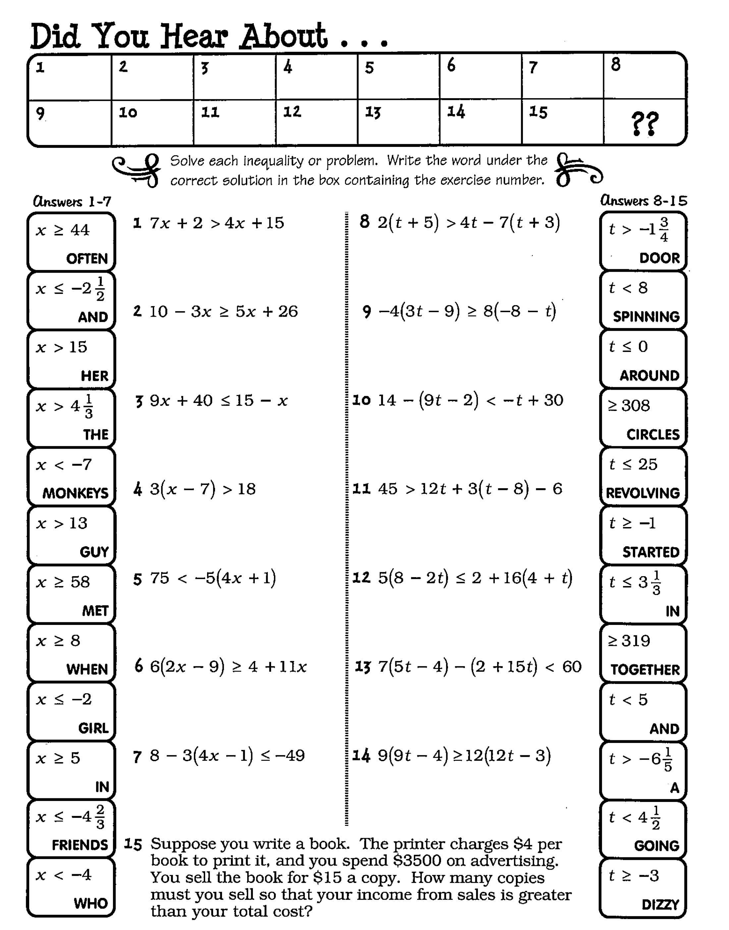
Directions: Show work on pages _______________

