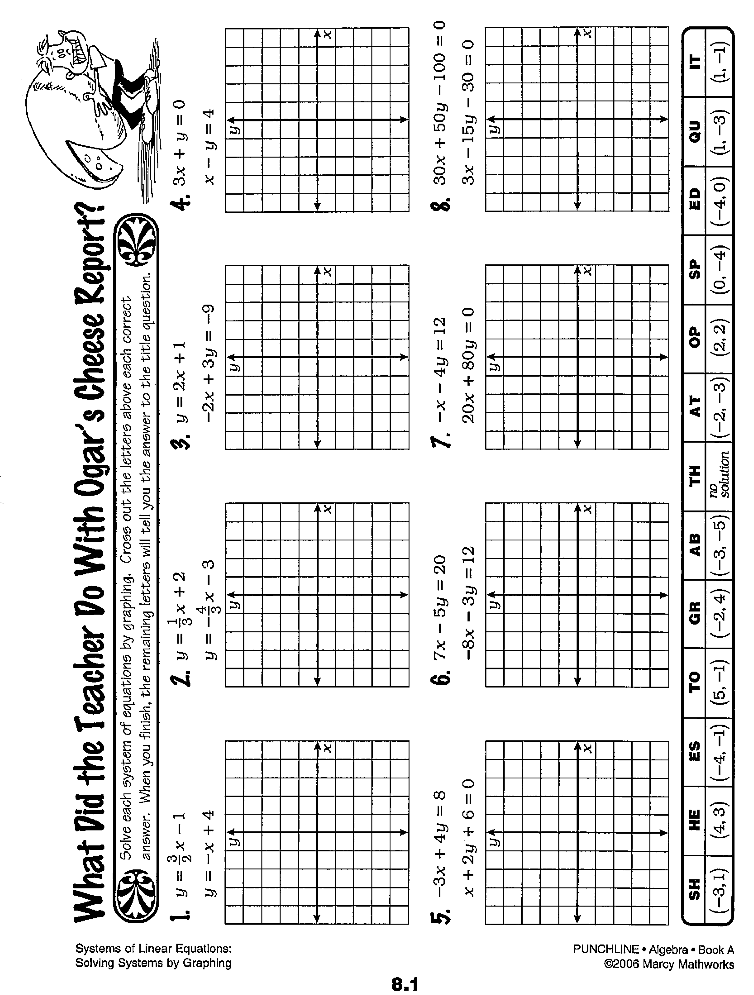

m = _____

b = ______

m = _____

b = ______

m = _____

b = ______

m = _____

b = ______

Name: _________________________________________________ Dec. 14

HW: Show work in your notebook for #s 3 – 8 on pages 58 & 59.